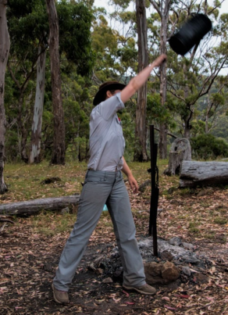**Billy Can Centrifuge**

**Aim:** To separate tea leaves from water using a centrifuge.

**Materials:**

* Plastic pot with handles
* Water
* Tea leaves
* String
* Spatula

**Method:**

1. Tie the string securely to the plastic pot handles.
2. Fill the pot ¾ full with water.
3. Put 2-3 spoonfuls of tea leaves into the water. Draw your observations of the particles.
4. Take the plastic pot outside and by holding the sting, spin it in a circle. Draw your observations of the particles.

**Results:**

|  |  |
| --- | --- |
| Before Spinning | After Spinning |
|  |  |

**Discussion:**

1. Which particles are the most dense? How do you know?
2. Why do the densest particles sink to the bottom?

1. Tea leaves mixed with water creates a suspension. Would centrifuging work on a solution? Why/why not?
2. Suggest another effective separation technique to separate tea leaves and water.

1. Describe a situation where centrifuging separation could be useful.